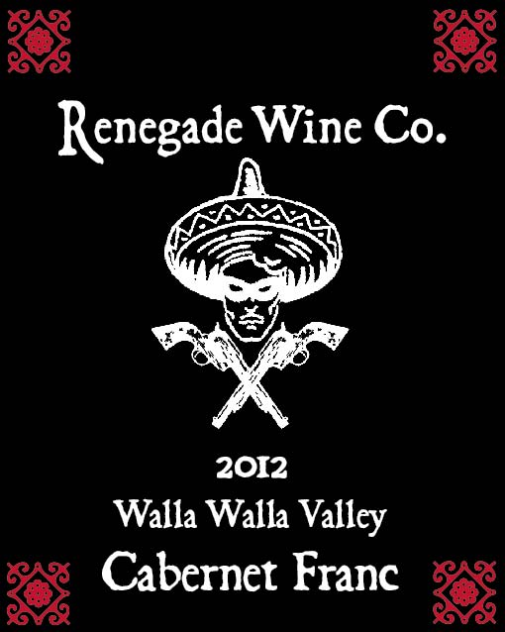

The Renegade Wine Co. is very excited to release the 2012 Walla Walla Valley Cabernet Franc. Less than 100 cases of this wine was produced, and after drinking a bottle, you’ll wish we made more! This Cab Franc was barrel aged for 16 months in two and three year old French oak barrels before bottling, All the classic Cab Franc characteristics are here, tobacco leaf, cocoa, red cherries, and a gorgeous layer of tannin to round out the rich mid palate. Like all the Renegade wines, this drinks as good as something twice as expensive. But you better pick this up soon, as it won’t sit on the shelf long….Only 95 cases produced.
Release date March 10th, 2014

